**Workshop: Cubicle - Part 1**

"*Cubicle*" is a place, where you can browse some of the most popular Rubik cubes in the world and add some new cubes that you have discovered.

## Folder Structure View

You're provided with a project structure skeleton like this:

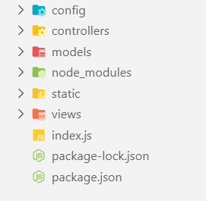

This structure includes the following configurations:

### Config Folder View

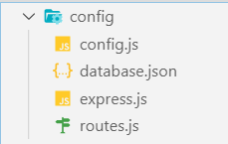

**Config.js**

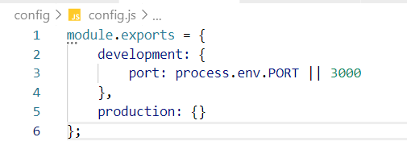

**Database.json**

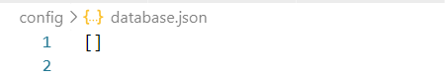

**Express.js**

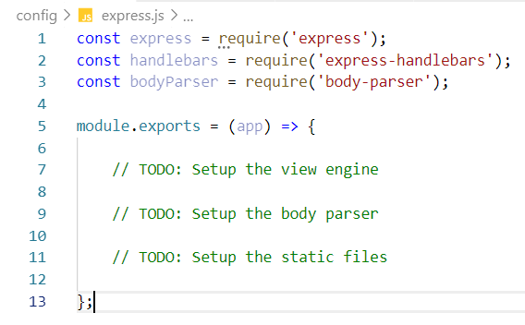

**Routes.js**

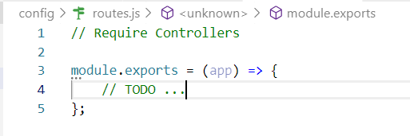

**Index.js**

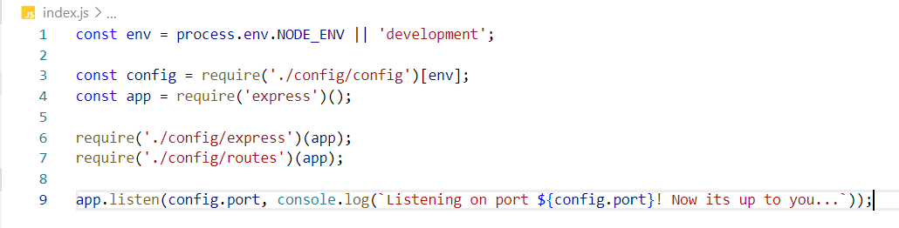

**Install Dependencies**

Run **'npm install'** to install all the dependencies.

## Create Model

### Cube Model

Each cube should have the following properties (for now it could be an ES6 class):

* **Id** - number
* **Name** – string
* **Description** – string
* **Image URL** – string
* **Difficulty** **Level**– number

## Storage

Store the cubes inside a **/config/database.json**

## Create Routes

You should implement the following routes:

* **/** - the main page (should visualize all the cubes in the database and a search field)
* **/about** – should render the about page
* **/create** – should render the create cube form
* **/details/:id** – should render the details page about selected cube
* **Any other** - should render the 404 not found page

### Main Page

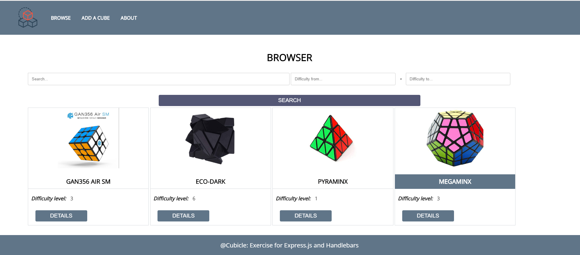

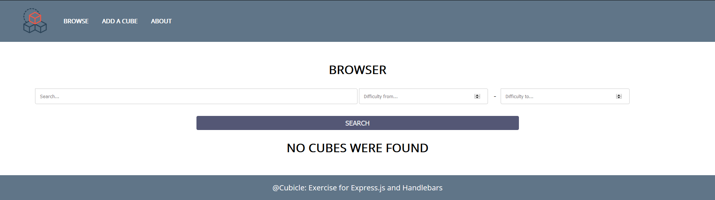

### About Page

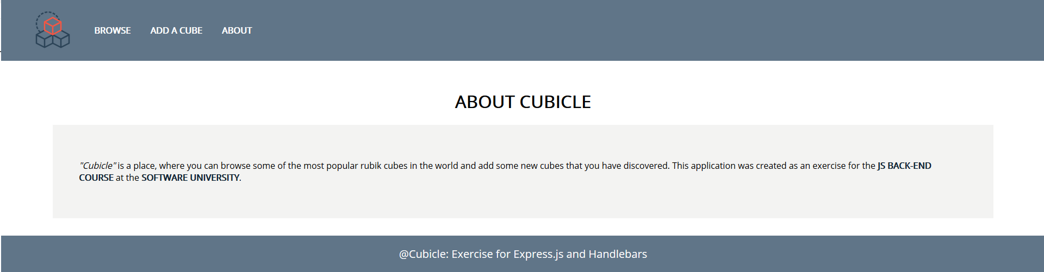

### Create Page

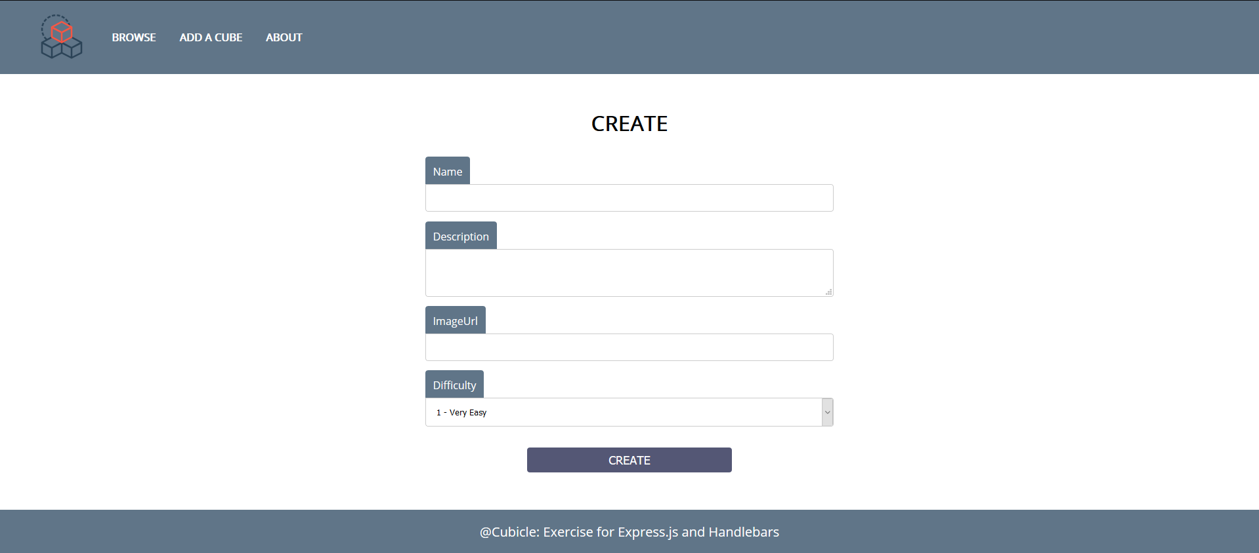

### Details Page

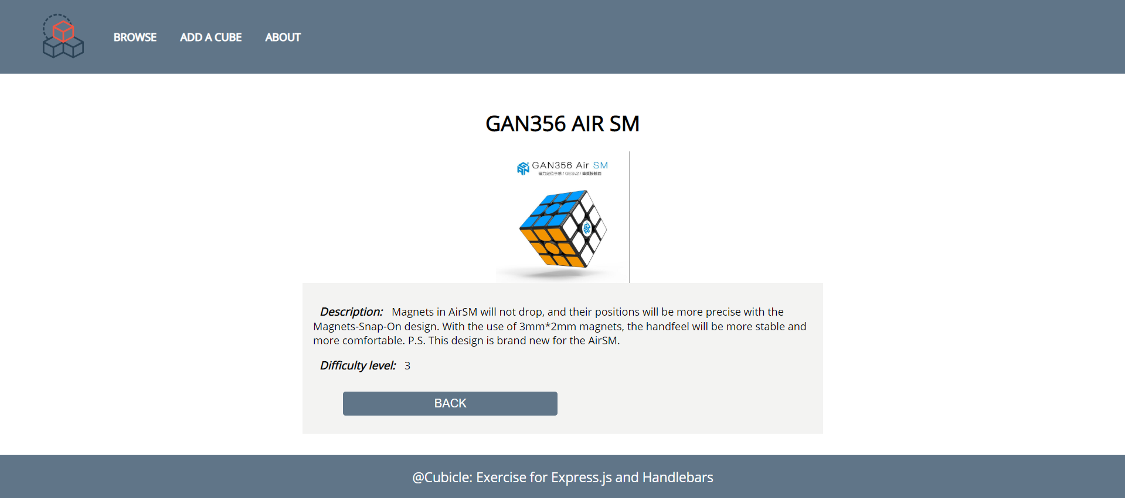

### Not Found Page



## Create Templates

Use the provided HTML to create templates using Handlebars. Identify the dynamic parts and use appropriate syntax for interpolating and rendering the application context.

## *Search

Implement searching logic. Use the following validation:

* If the user searches **only** a string and **NO difficulty**, render **all difficulties**

If the search does ***NOT*** meet the requirements, just **redirect** to the home page **('/').**

**Good Luck! 😊**